
Task # 03
Name : Nabiha Sabir
Roll no : bssem-s24-019
Section :5A
Subject :Computer Network lab
Submitted to : mam

Task 1: Star Topology
Question:
Create a Star Topology using one switch and four PCs in Cisco Packet Tracer.
- Assign IP addresses in the same subnet.
- Test communication by pinging all PCs from PC0.

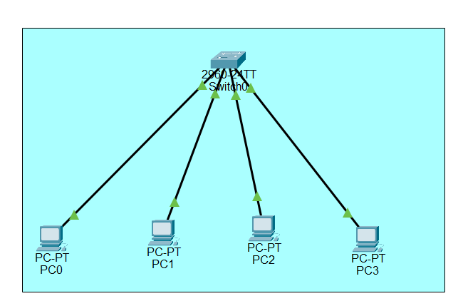
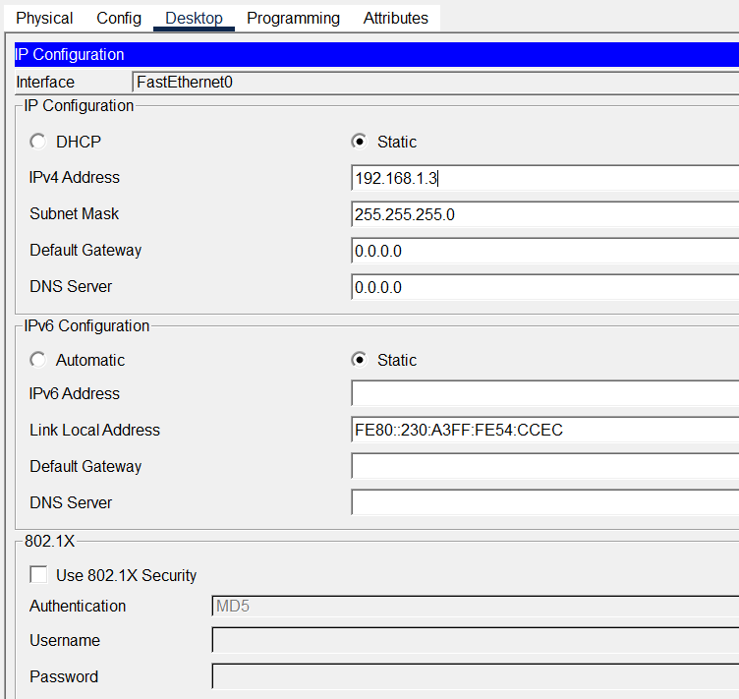
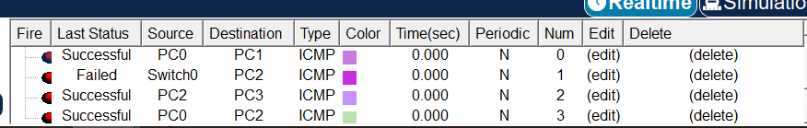
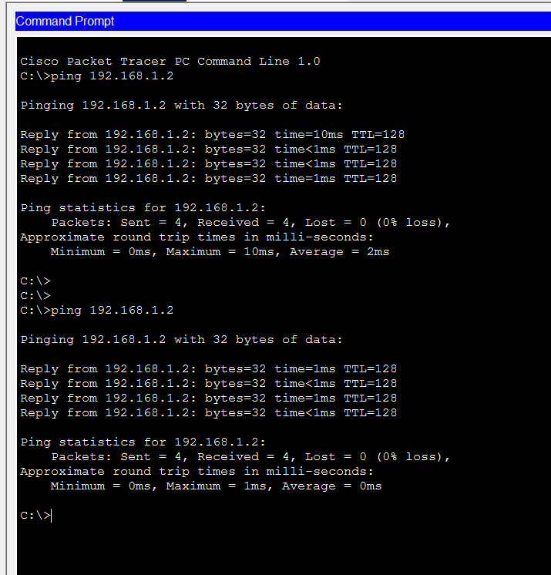

Task 2: Bus Topology
Question:
Simulate a Bus Topology using one hub and four PCs in Cisco Packet Tracer.
- Assign IP addresses in the same subnet.
- Verify communication by pinging PC1, PC2, and PC3 from PC0.
- 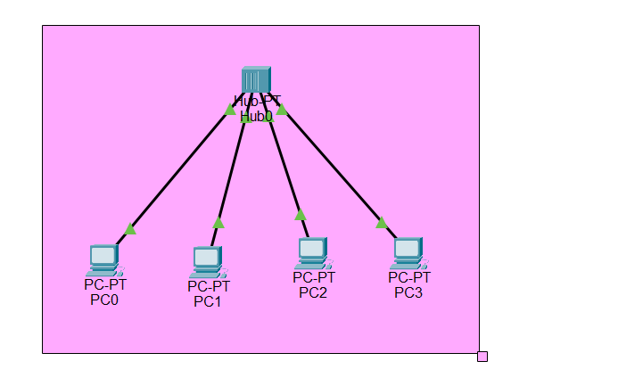

Task 3: Ring Topology Simulation (with Switches)
Question:
Design a Ring Topology by connecting four switches in a circle.
- Connect one PC to each switch.
- Assign IP addresses to PCs in the same subnet.
- Test communication by sending pings around the ring (PC0 → PC1 → PC2 → PC3).
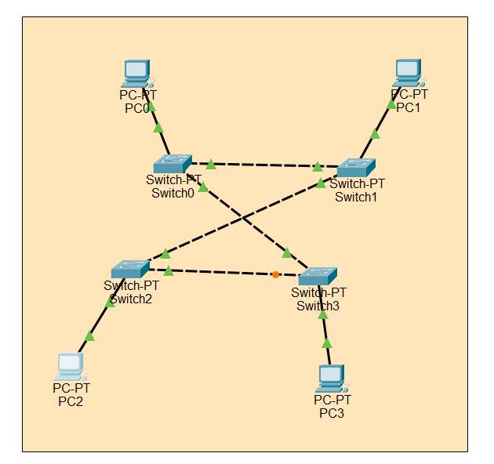
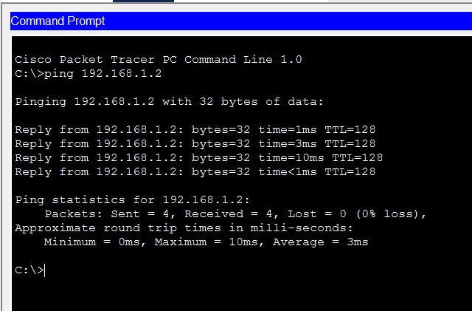

Task 4: Mesh Topology (with Switches)
Question:
Build a Partial Mesh Topology using three switches.
- Connect the switches to each other.
- Connect two PCs to each switch.
- Assign IP addresses in the same subnet.
- Verify that all PCs can communicate with each other.
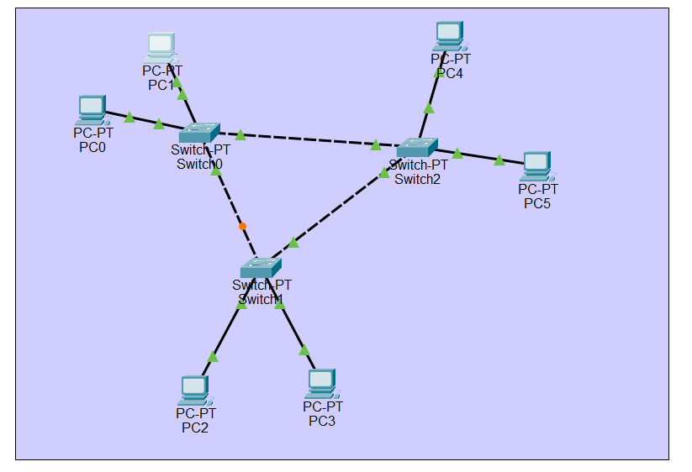
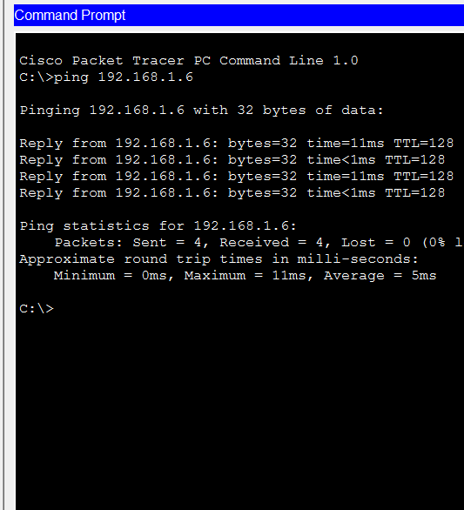
Task 5: Tree (Hierarchical) Topology
Question:
Create a Tree Topology using one main switch, two sub-switches, and six PCs (three per sub-switch).
- Assign IP addresses in the same subnet.
- Test communication between PCs in different branches (e.g., PC0 → PC5).
- 